**UJIAN TENGAH SEMESTER**

**PENGANTAR AKUNTANSI**

***SEMESTER 2***



**Disusun oleh:**

**Rama Pramudya Wibisana 2022320019**

**PROGRAM STUDI SISTEM INFORMASI**

**FAKULTAS INFORMATIKA**

**UNIVERSITAS BINA INSANI**

**BEKASI**

**2023**

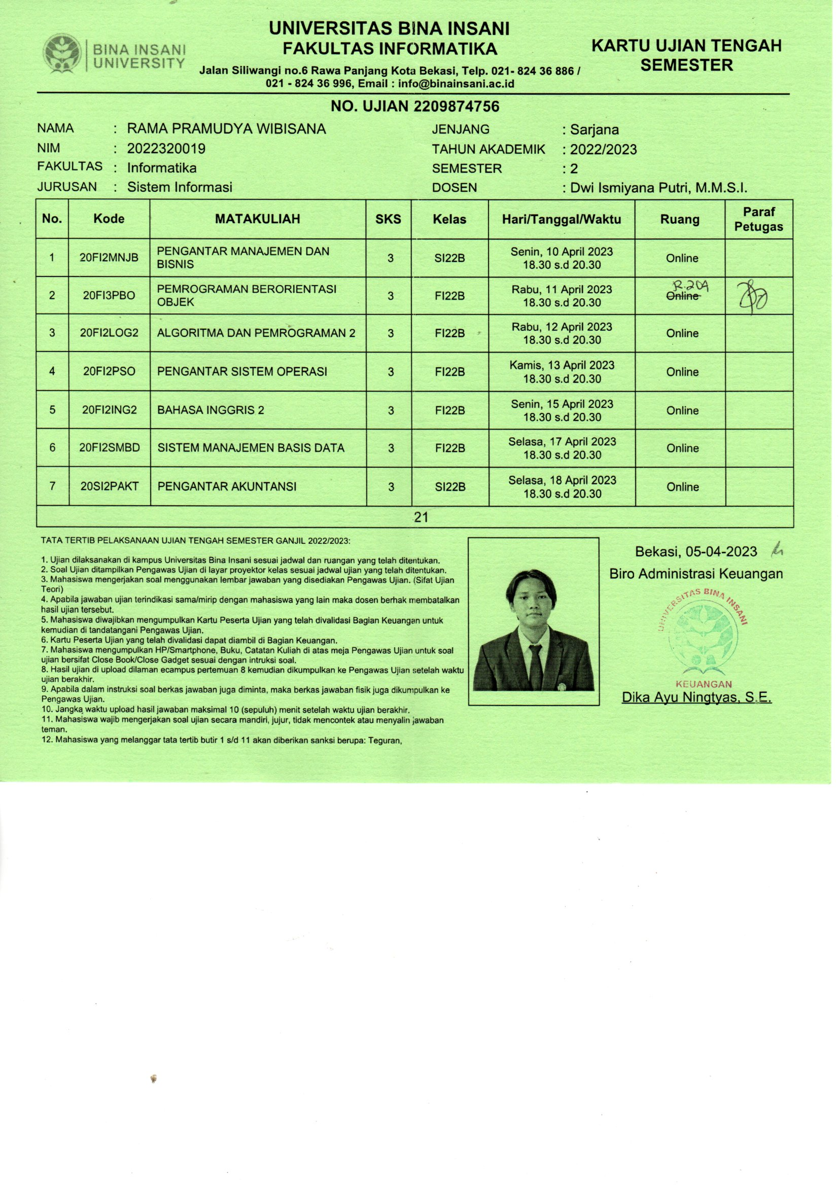

**Soal I**

Karena ini merupakan prinsip yang sangat penting dalam melakukan pembukuan suatu laporan keuangan. Contohnya ialah utang, piutang, aktiva, modal, dan penghasilan.

**Soal II**

Akun : **KAS**

|  |  |  |  |  |  |  |  |
| --- | --- | --- | --- | --- | --- | --- | --- |
| Tgl | Keterangan | Ref | Jumlah | Tgl | Keterangan | Ref | Jumlah |
| 16 Maret |  | 11 | Rp. 50.000 |  |  |  |  |

Akun : **MODAL**

|  |  |  |  |  |  |  |  |
| --- | --- | --- | --- | --- | --- | --- | --- |
| Tgl | Keterangan | Ref | Jumlah | Tgl | Keterangan | Ref | Jumlah |
|  |  |  |  | 16 Maret |  | 11 | Rp. 50.000 |

Akun : **PERALATAN**

|  |  |  |  |  |  |  |  |
| --- | --- | --- | --- | --- | --- | --- | --- |
| Tgl | Keterangan | Ref | Jumlah | Tgl | Keterangan | Ref | Jumlah |
| 16 |  | 16 | Rp. 7.500 |  |  |  |  |

Akun : **BEBAN SEWA KANTOR**

|  |  |  |  |  |  |  |  |
| --- | --- | --- | --- | --- | --- | --- | --- |
| Tgl | Keterangan | Ref | Jumlah | Tgl | Keterangan | Ref | Jumlah |
| 17 |  | 53 | Rp. 3.500,000 |  |  |  |  |

Akun : **BEBAN TRUK**

|  |  |  |  |  |  |  |  |
| --- | --- | --- | --- | --- | --- | --- | --- |
| Tgl | Keterangan | Ref | Jumlah | Tgl | Keterangan | Ref | Jumlah |
| 18 |  | 55 | Rp. 90.000  15.000  75.000 |  |  |  |  |

Akun : **PIUTANG USAHA**

|  |  |  |  |  |  |  |  |
| --- | --- | --- | --- | --- | --- | --- | --- |
| Tgl | Keterangan | Ref | Jumlah | Tgl | Keterangan | Ref | Jumlah |
|  |  |  |  | 19  26 |  | 12  12 | Rp. 4.000  37.500 |

Akun : **PERLENGKAPAN**

|  |  |  |  |  |  |  |  |
| --- | --- | --- | --- | --- | --- | --- | --- |
| Tgl | Keterangan | Ref | Jumlah | Tgl | Keterangan | Ref | Jumlah |
|  |  |  |  | 22 |  | 12 | Rp. 1.250 |

Akun : **BEBAN GAJI**

|  |  |  |  |  |  |  |  |
| --- | --- | --- | --- | --- | --- | --- | --- |
| Tgl | Keterangan | Ref | Jumlah | Tgl | Keterangan | Ref | Jumlah |
| 23  31 |  | 51  51 | Rp. 6.000  6.500 |  |  |  |  |

Akun : **ASURANSI**

|  |  |  |  |  |  |  |  |
| --- | --- | --- | --- | --- | --- | --- | --- |
| Tgl | Keterangan | Ref | Jumlah | Tgl | Keterangan | Ref | Jumlah |
| 23 |  | 14 | Rp. 4.150 |  |  |  |  |

Akun : **PENDAPATAN JASA**

|  |  |  |  |  |  |  |  |
| --- | --- | --- | --- | --- | --- | --- | --- |
| Tgl | Keterangan | Ref | Jumlah | Tgl | Keterangan | Ref | Jumlah |
| 29  31 |  | 41  41 | Rp. 4.100  22.500 |  |  |  |  |

Akun : **PENDAPATANM JASA**

|  |  |  |  |  |  |  |  |
| --- | --- | --- | --- | --- | --- | --- | --- |
| Tgl | Keterangan | Ref | Jumlah | Tgl | Keterangan | Ref | Jumlah |
| 29 |  | 55 | Rp. 920 |  |  |  |  |

Akun : **BEBAN LISTRIK**

|  |  |  |  |  |  |  |  |
| --- | --- | --- | --- | --- | --- | --- | --- |
| Tgl | Keterangan | Ref | Jumlah | Tgl | Keterangan | Ref | Jumlah |
| 30 |  | 54 | Rp. 1.050 |  |  |  |  |

Akun : **BEBAN LAIN LAIN**

|  |  |  |  |  |  |  |  |
| --- | --- | --- | --- | --- | --- | --- | --- |
| Tgl | Keterangan | Ref | Jumlah | Tgl | Keterangan | Ref | Jumlah |
| 30 |  | 59 | Rp. 450 |  |  |  |  |

Akun : **PRIVE**

|  |  |  |  |  |  |  |  |
| --- | --- | --- | --- | --- | --- | --- | --- |
| Tgl | Keterangan | Ref | Jumlah | Tgl | Keterangan | Ref | Jumlah |
| 31 |  | 54 | Rp. 7.500 |  |  |  |  |

**JURNAL UMUM PERUSAHAAN DEKORASI**

**HAPSARI INDAH**

|  |  |  |  |  |
| --- | --- | --- | --- | --- |
| **TGL** | **KETERANGAN** | **REF** | **DEBIT** | **KREDIT** |
| **16** | **KAS**  **MODAL** | **11**  **31** | **RP. 50.000** | **RP. 50.000** |
| **16** | **PERALATAN**  **KAS** | **16**  **11** | **RP. 7.500** | **RP. 7.500** |
| **17** | **PERLENGKAPAN**  **KAS** | **13**  **11** | **RP. 1.750** | **RP. 1.750** |
| **18** | **BEBAN TRUK**  **KAS** | **55**  **11** | **RP. 90.000** | **RP. 15.000**  **RP. 75.000** |
| **19** | **PENDAPATAN**  **KAS** | **41**  **11** | **RP. 4.000** | **RP. 4.000** |
| **22** | **PERLENGKAPAN**  **KAS** | **13**  **11** | **RP. 1.250** | **RP. 1.250** |
| **23** | **BEBAN GAJI**  **KAS** | **51**  **11** | **RP. 6.000** | **RP. 6.000** |
| **23** | **BEBAN PREMI ASURANSI**  **KAS** | **14**  11 | **RP. 4.150** | **RP. 4.150** |
| **25** | **UTANG USAHA  KAS** | **21**  **11** | **RP. 7.500** | **RP. 7.500** |
| **26** | **PIUTANG USAHA**  **PENDAPATAN JASA** | **12**  **41** | **R. 37.500** | **RP. 37.500** |
| **29** | **KAS**  **PENDAPATAN** | **11**  **41** | **RP. 4.100** | **RP. 4.100** |
| **29** | **BEBAN TRUK**  **UTANG USAHA** | **55**  **22** | **RP. 920** | **RP. 920** |
| **30** | **BEBAN LISTRIK**  **KAS** | **54**  **11** | **RP. 1.050** | **RP. 1.050** |
| **31** | **PENDAPATAN**  **KAS** | **41**  **11** | **RP. 22.500** | **RP. 22.500** |
| **31** | **GAJI**  **KAS** | **51**  **11** | **RP. 6.500** | **RP. 6.500** |
| **31** | **PRIVE**  **KAS** | **32**  **11** | **RP. 7.500** | **RP. 7.500** |

|  |  |  |
| --- | --- | --- |
| **AKUN** | **DEBIT** | **KREDIT** |
| **KAS** | **RP. 50.000** |  |
| **PIUTANG USAHA** | **RP. 37.500** |  |
| **PERLENGKAPAN** | **RP. 1.250** |  |
| **ASURANSI** | **RP. 4.150** |  |
| **PERALATAN** | **RP. 7.500** |  |
| **TRUK** | **RP. 15.000** |  |
| **UTANG WESEL** |  | **RP.75.000** |
| **UTANG USAHA** |  | **RP. 7.500** |
| **MODAL HESTI** |  | **RP. 50.000** |
| **PRIVE HESTI** | **RP. 7.500** |  |
| **PENDAPATAN JASA** |  | **RP. 26.500** |
| **BEBAN GAJI** | **RP. 12.500** |  |
| **BEBAN SEWA** | **RP. 3,000,000** |  |
| **BEBAN LISTRIK** | **RP. 1.050** |  |
| **BEBAN TRUK** | **RP. 920** |  |
| **BEBAN LAIN LAIN** | **RP. 450** |  |
|  |  |  |

**Soal III**

Mohon maaf waktu tidak cukup pak